Grade 9 Social Studies: Residential Schools
Sugar Falls: As Residential School Story by David Alexander Robertson (Author), and Scott B. Henderson (Illustrator)
Outcomes:
- DR9.4 Determine the influence of societies of the past on contemporary life in Canada.
- PA9.2 Analyze the impact of empire-building and territorial expansion on indigenous populations and other groups in the societies studied.
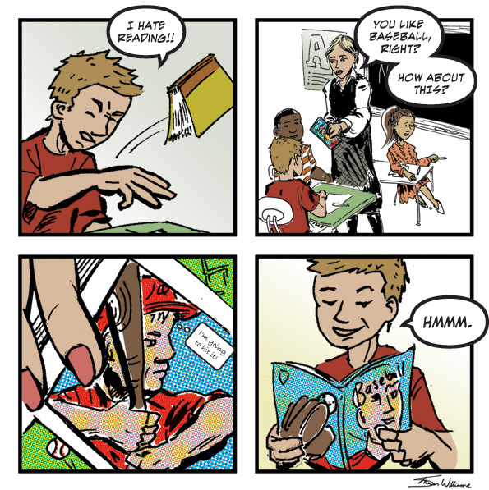
Review: How do we read graphic novels?

Which one do I read first?
Which do I read second? Do I read the top bubble or the bottom bubble first?

Day 1:
Read the graphic novel Sugar Falls. You may read silently or share a book with a partner and read together if there is not enough for everyone.
Theme: The book explores several themes:
- ____________________________________

- ____________________________________

- ____________________________________

Relationships:
- What are different types of relationships that this book explored??

• ____________________________________

• ____________________________________

• ____________________________________

• ____________________________________

• ____________________________________

- What does it mean to have a relationship with a place?

___________________________________________________

___________________________________________________

___________________________________________________

- Describe a place that has significant meaning to you and why. Describe where it is located, use your five senses to tell me what it looks like, feel like, smells like etc. and tell me why it is so important to you.
___________________________________________________
___________________________________________________
___________________________________________________
___________________________________________________
___________________________________________________
___________________________________________________
___________________________________________________
___________________________________________________
___________________________________________________

- How does our experiences and relationships in the past, affect our future? Explain your thoughts?
___________________________________________________
___________________________________________________
___________________________________________________
___________________________________________________
___________________________________________________
___________________________________________________

- Brainstorm significant relationships that you might have with a person, place or an object. You will be able to take photos next class and edit them to create a graphic/sketch image.

___________________________________________________

___________________________________________________

___________________________________________________

Day 2:
Photography Assignment: You are going to create your own graphic picture using the theme of relationship. You must use a camera or your phone to take photos of a relationship that you have with a person, place or an object. You will have to write a paragraph explaining the message of your picture.
Step 1: Camera or a phone.
Step 2: Take photos exploring the theme of relationship. (or you can use one you already have – this will save lots of time)
Step 3: Upload photos from camera to computers (you can insert memory cards directly into laptops or you must use the cord to transfer picture or you can e-mail from your phone). **this is the hardest step. Save to my photos in your h drive!!!!
Step 4: Upload your photo to ribbet.
- Go to http://www.ribbet.com/
- Click on edit photo
- Click on upload photo (and go find where you saved it)
- Find the little frog in the top menu bar and click on effects
- Change the photo to black and white and click apply.
- Scroll down the options on the right side until you see pencil sketch. Play with the settings until you are happy and click apply.
- If you want to play around with image, go to the top menu bar and click on basic edits.
Step 5: Save your image by clicking on save button top. Name your photo.
Step 6: Open up Microsoft word and copy and paste your picture in a document.
Step 7: Put a title and your name on it.
Step 8: Write a three to five sentences describing your picture and the theme or relationship.
Step 9: Hand in.

A Day at Katepewa Beach by Kendra Beliveau

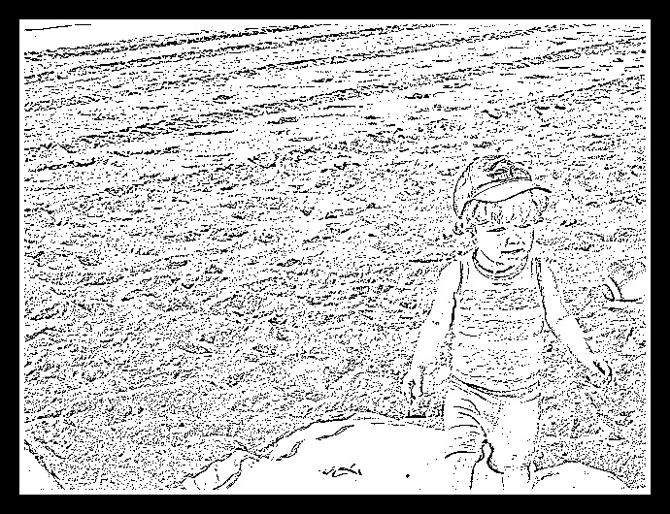

This is a picture of my son Harrison in the summer of 2013 at Katepewa beach. He loves to play in the sand. There was sand in our water bottles, sand on the blanket and sand in our clothes but we were both so happy. This is the beach that I took my swimming lessons at with my grandparents every summer. Every time I return to this place, I think of many happy summers as a kid eating ice cream, swimming, playing sports and hanging with my friends. I hope one day Harrison will take swimming lessons here too.

